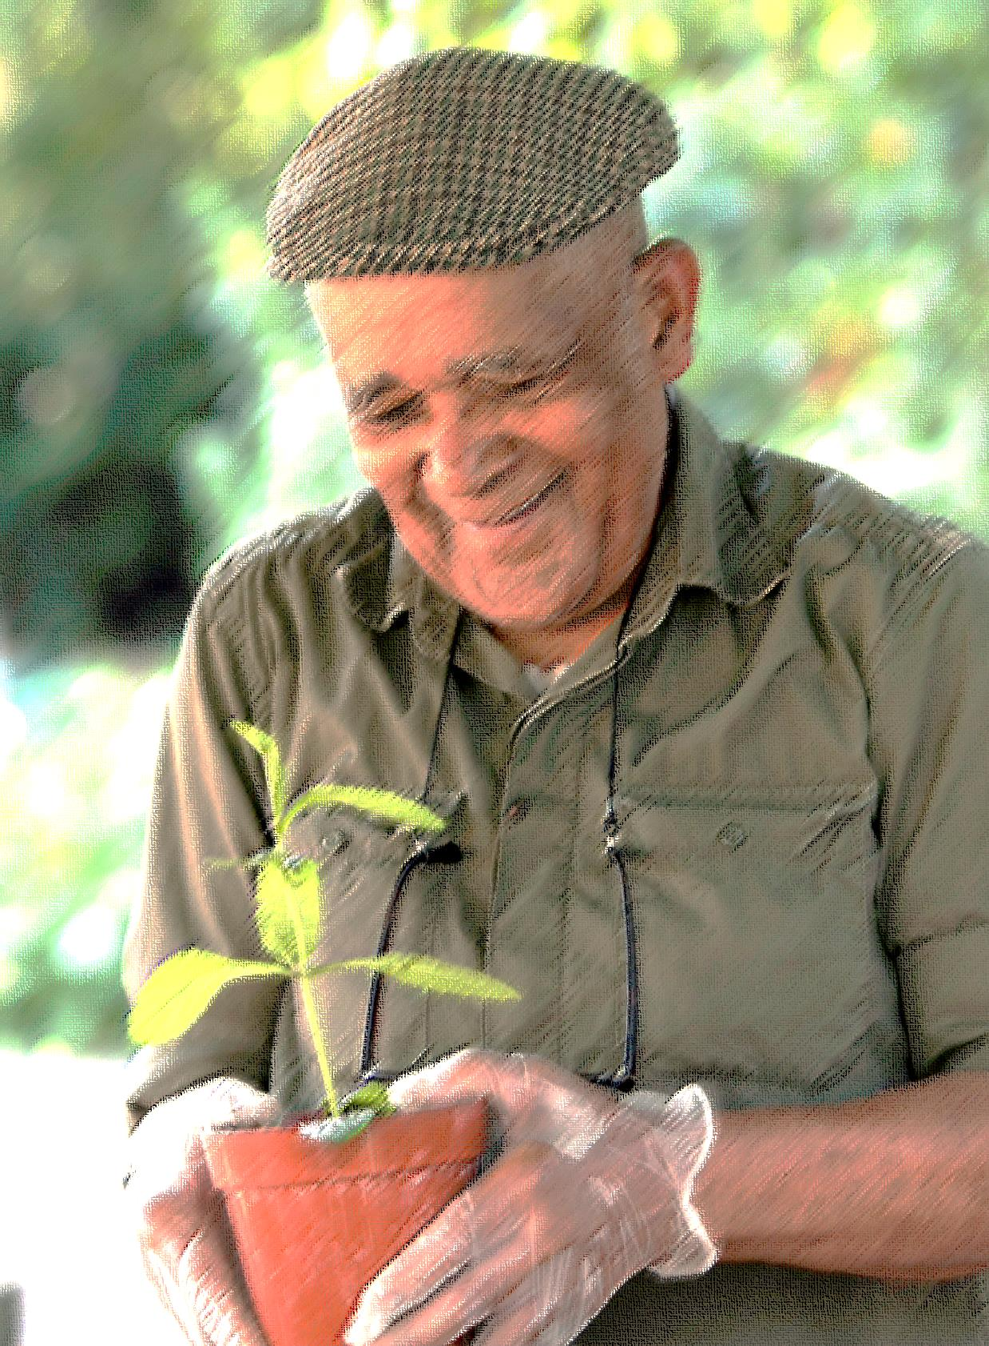
Vintage Gardening Club at St Mary’s Secret Garden – Members needed
Are you over 60? Enjoy digging the earth? Eating food? Meeting others? Gaining new skills or sharing and refreshing old ones? Then please join us
St Mary’s Secret Garden is launching a new gardening and grub club for people over 60yrs old
- Meet once a week on Thursday mornings at the garden
- Develop gardening and volunteering skills
- Themed workshops throughout the programme including: herbal , art, floristry, ‘ yard to jar’, beekeeping and many more
- Opportunity to join us for training in first aid and safeguarding vulnerable people
- Create lunch to share, harvesting ingredients from the garden
- Develop a recipe book to share
Programme starting Thursday 25th September 9.30 a.m. - 1.30 p.m. for 5 months.
Please contact the garden for further information or pop round, have a chat and find out more. Ask for Antoinette or Paula.
Our garden is fully accessible. Gardening is proved to make you feel good – come and see if it works for you!
Contact us on 02077392965 or email info@stmarysgarden.org.uk
50 Pearson Street E2 8EL
Website: www.stmaryssecretgarden.org.uk
St Mary’s Secret Garden Registered charity 1152027 Company limited by guarantee 05987612

